**PUP Application For Re-Admission Form**

**Members:**

Mijares, Jaira C

Porlares, Alexander S.

**Github Repository:** <https://github.com/Rednaxela5/PUP-AFRA-Form>

**Timeline:**

* **October 24, 2023**
  + Selection of manual form that will be converted into website.
  + Task 1
  + 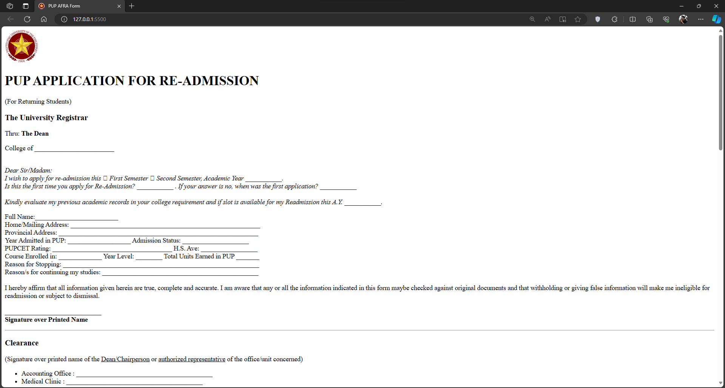Initial setup of the repository and website.

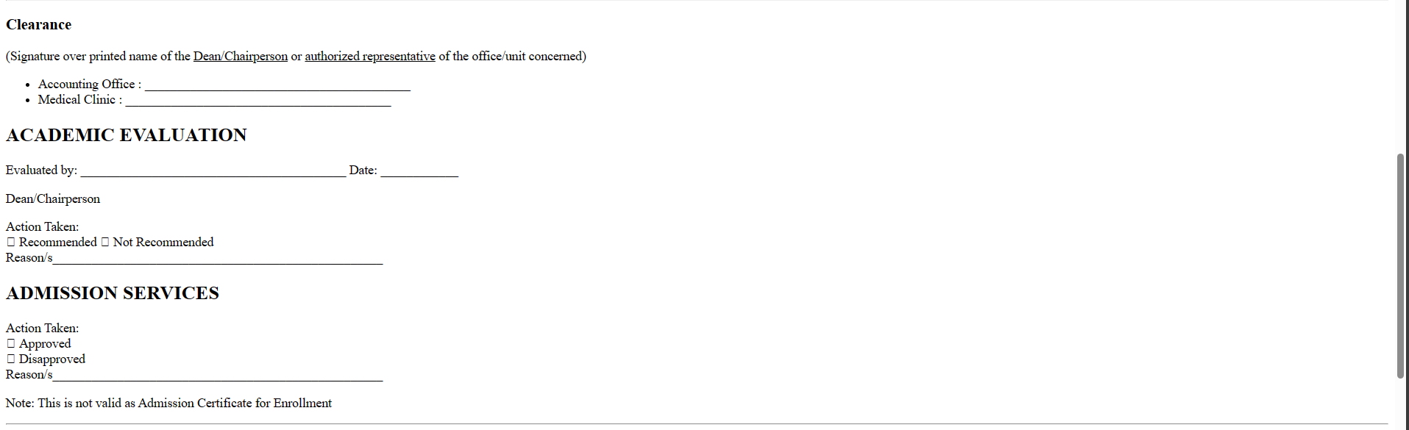

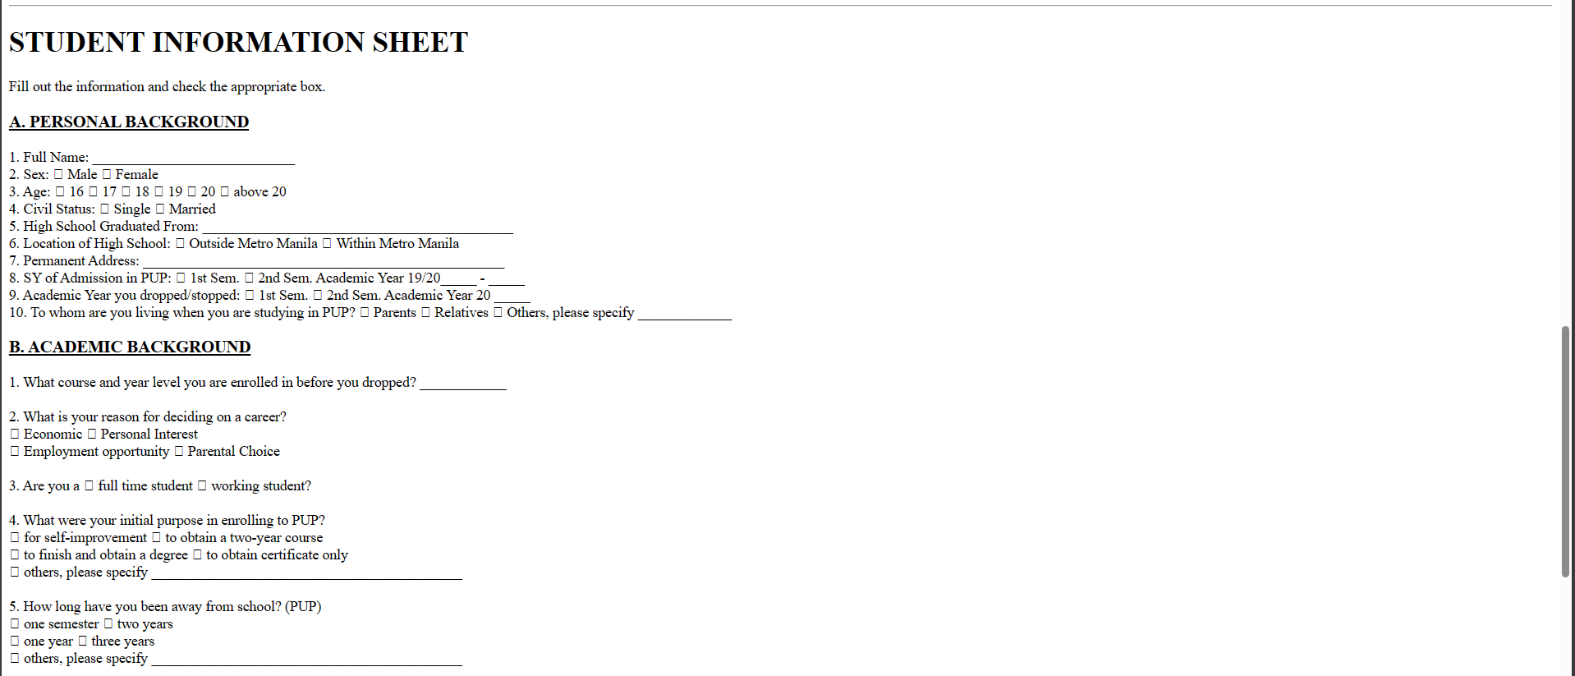

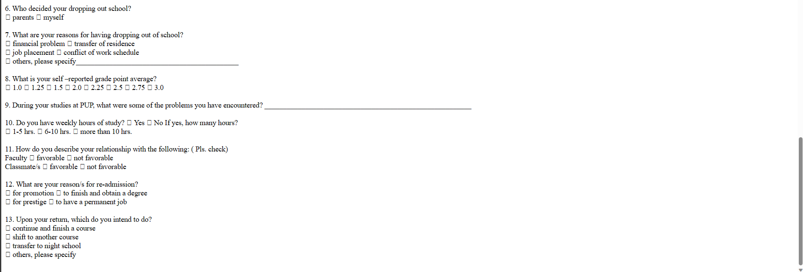

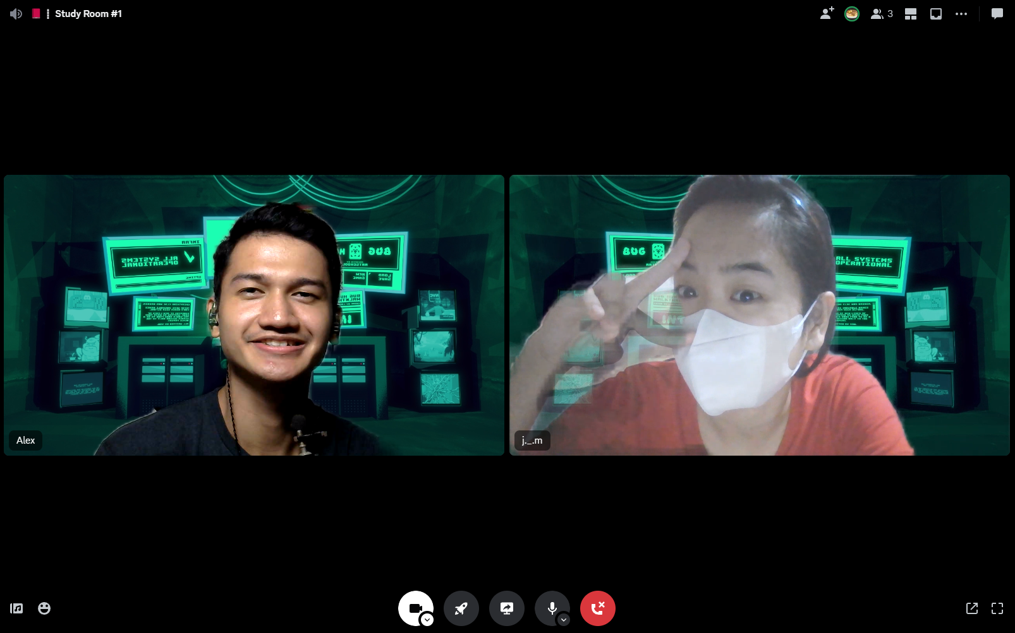

* **October 31, 2023 (8:30 PM – 2:00 AM)**
  + Setup and Learned Figma.
  + Compiled the resources needed for design (color palette, pictures, font styles, design ideas)
  + Design the website in Figma.

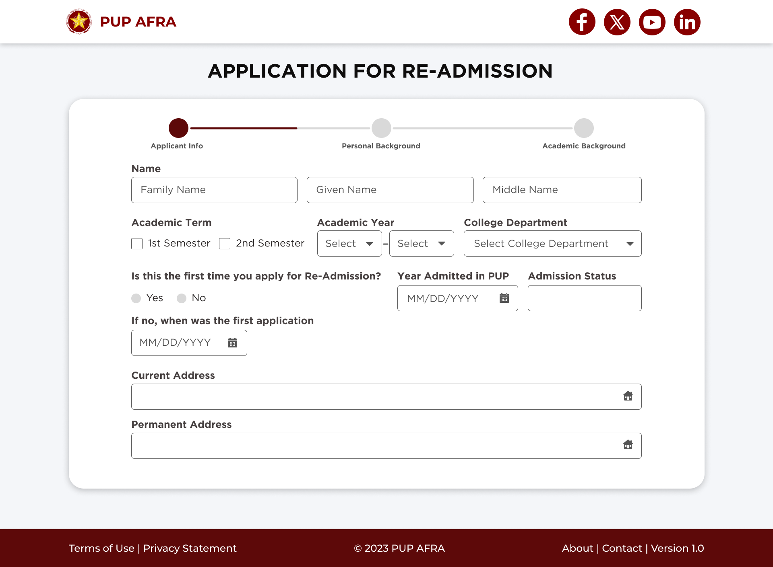

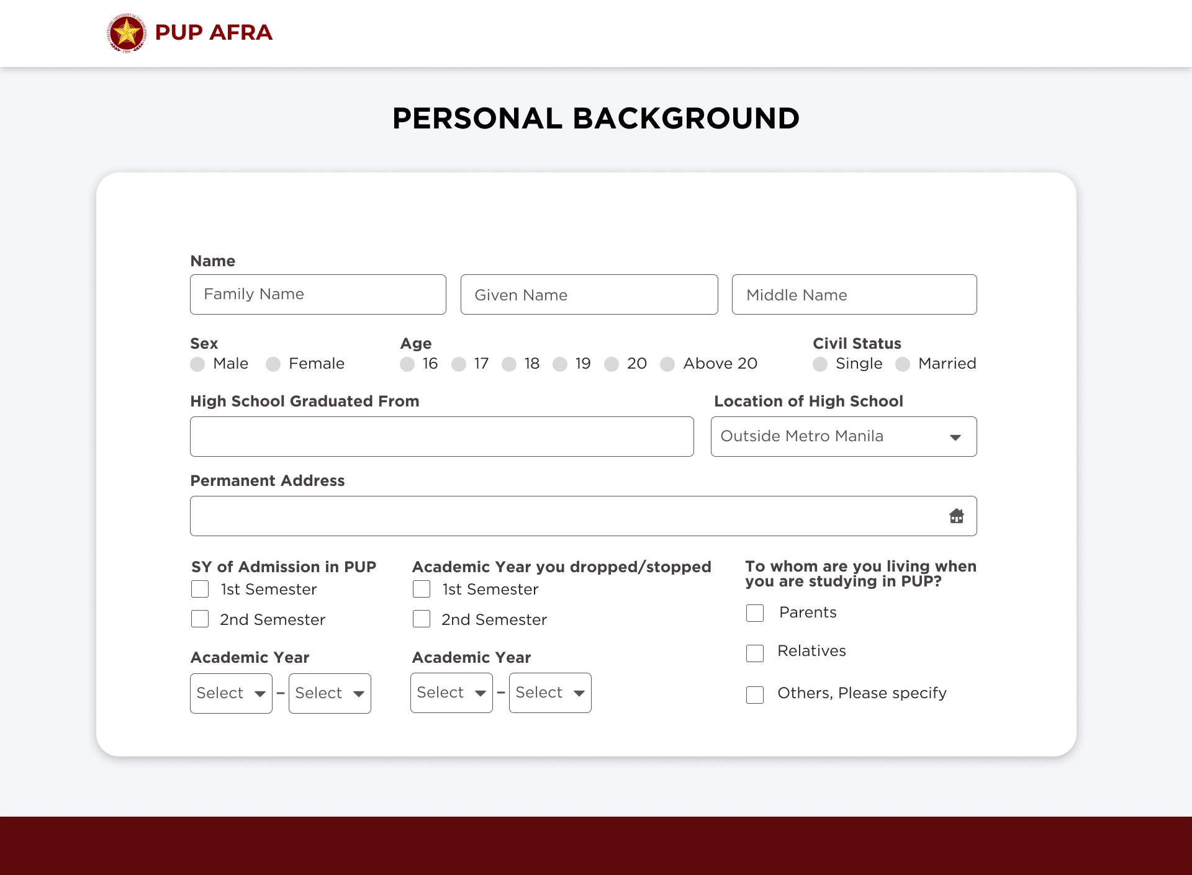

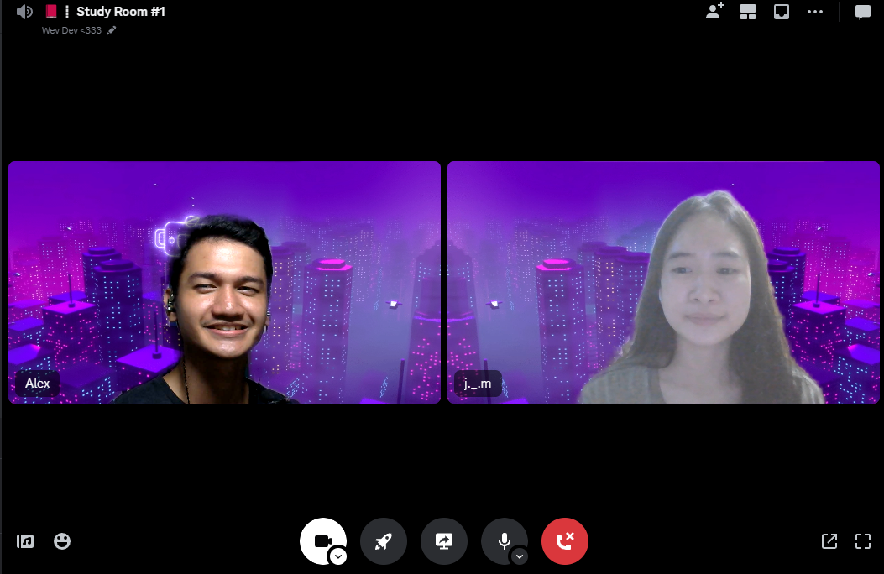

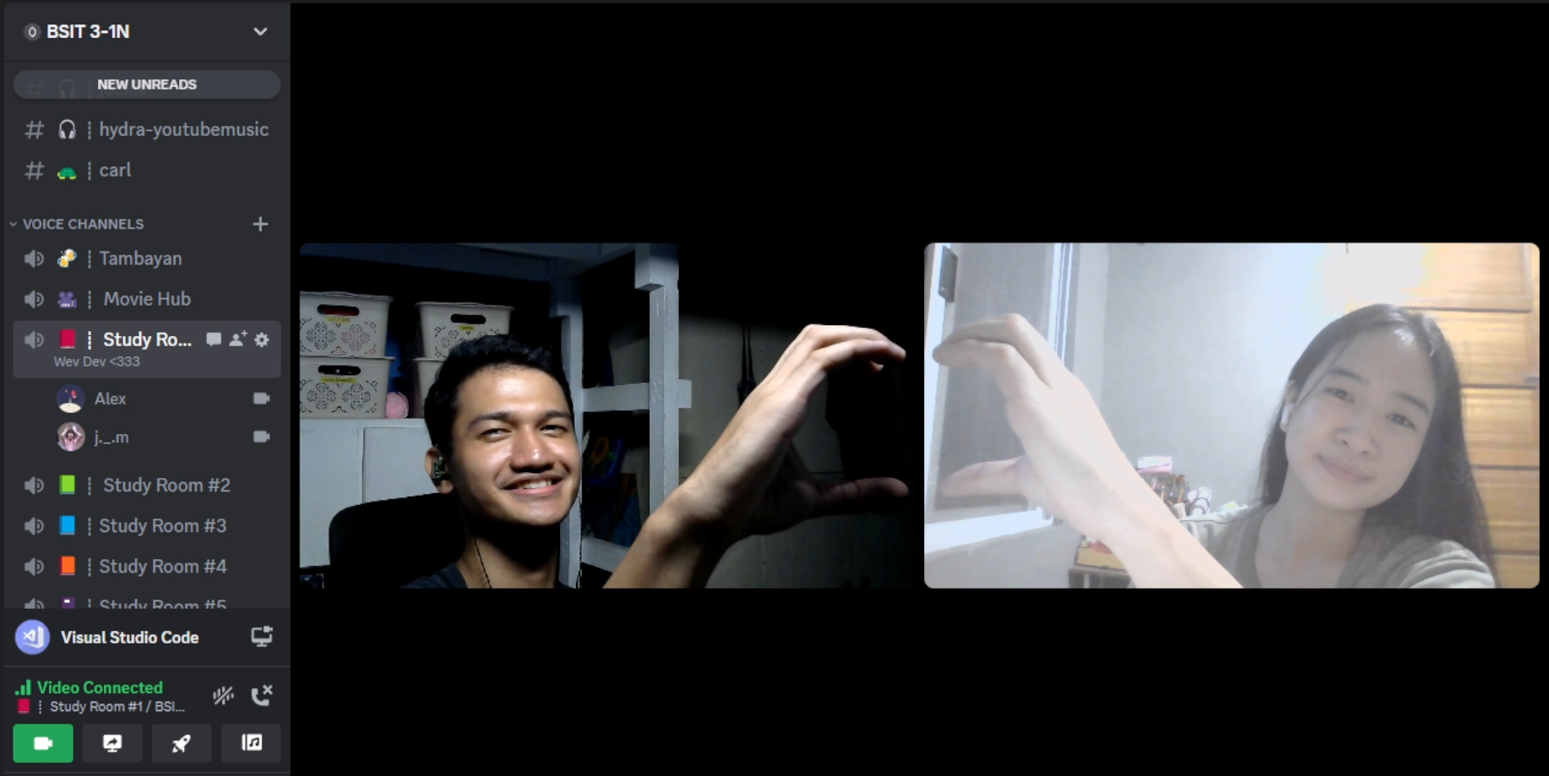

* **November 07, 2023 (9:15 PM – 3:00 AM)**
  + Continue designing the website in Figma.
  + Brainstorm ideas on what approach can be made in address. (Found out Philippine Address Locator: <https://github.com/wilfredpine/philippine-address-selector>) – it uses Location API
  + **Next Step:**
* Home Page (Design)
* Thank You Page (Design)

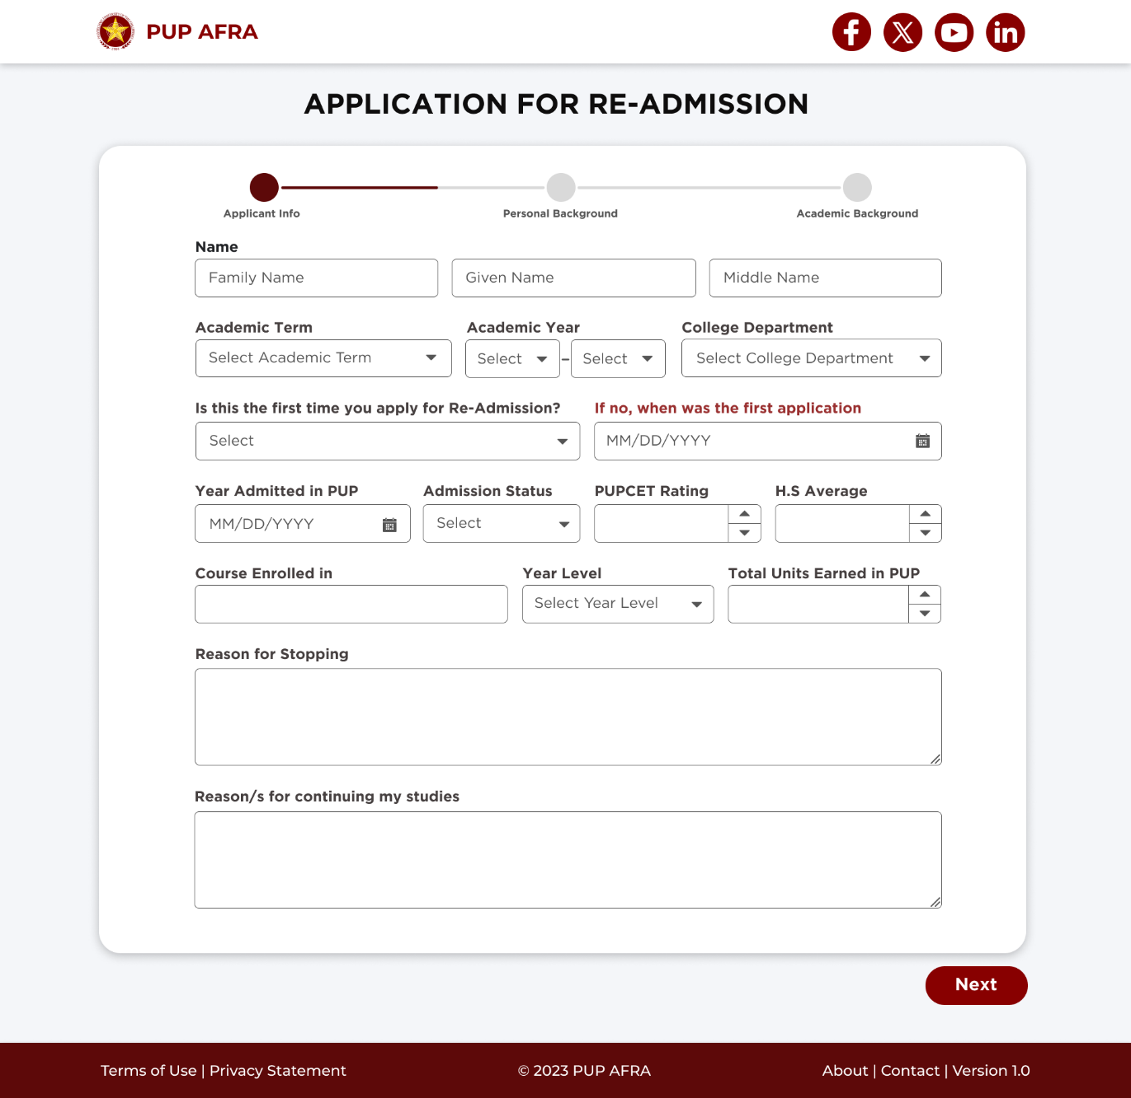

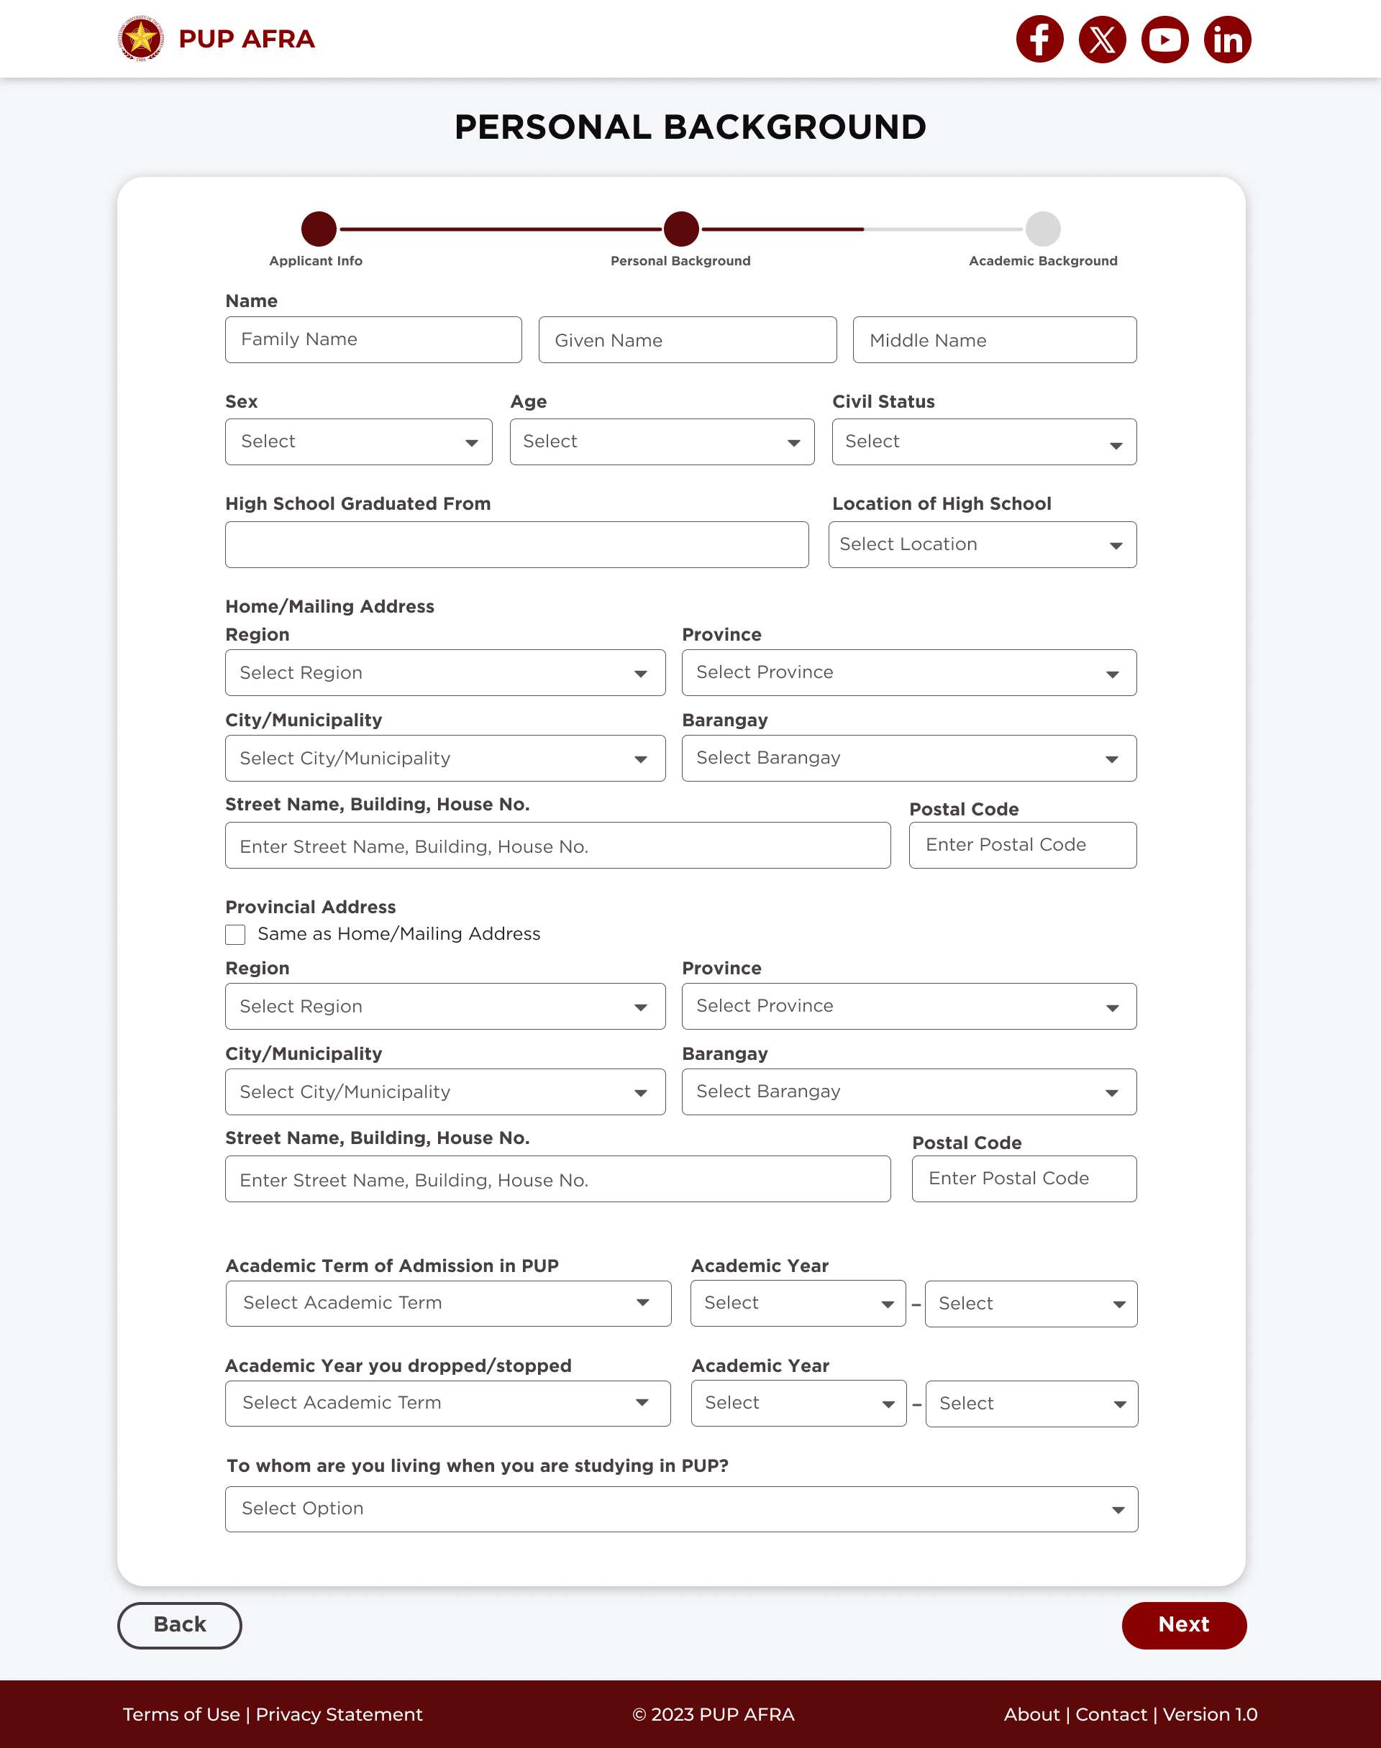

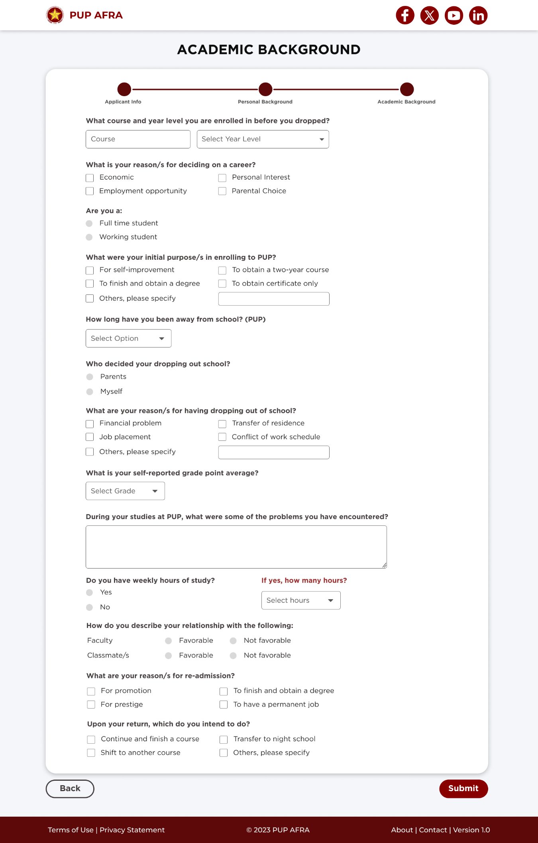

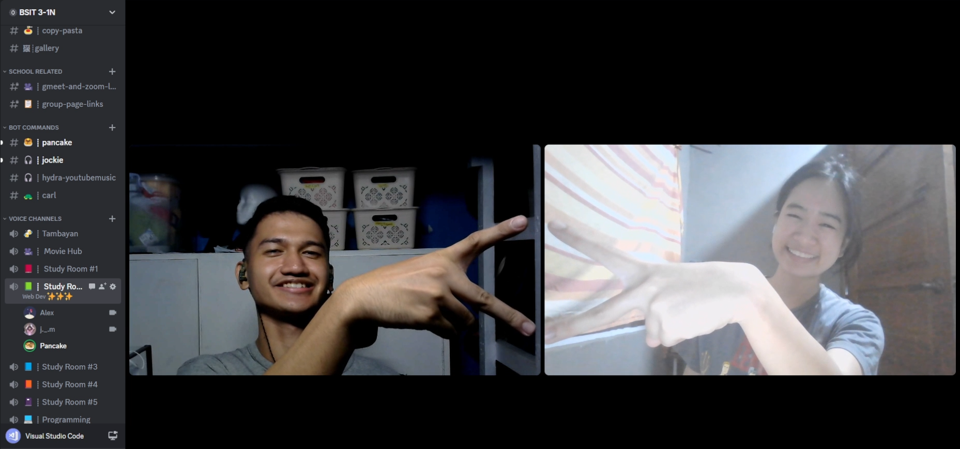

* **November 14, 2023 (9:00 PM – 1:50 AM)**
  + Continue designing the website in Figma.
    - Finished “Thank You Page” Design
    - Continue making “Homepage/Landing Page” Design
  + Used Canva for editing pictures for the homepage.
  + Made a basic prototyping in figma to simulate the next, back, return home buttons.
  + **Next Step:**
* Finalize the Home Page
* Optimize the process of application (manual-digital)
* Documents Submission Page (Design)

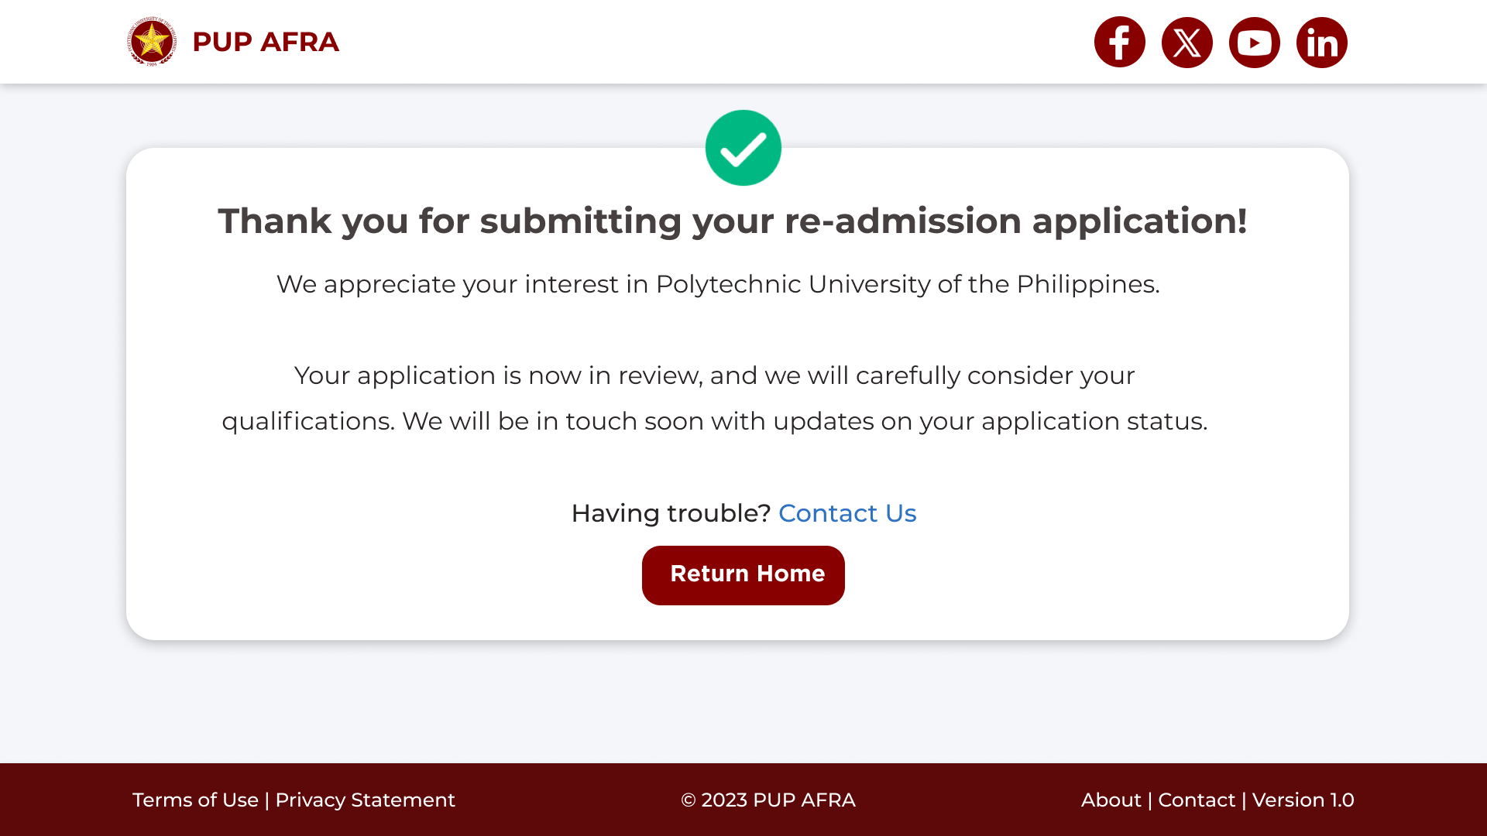

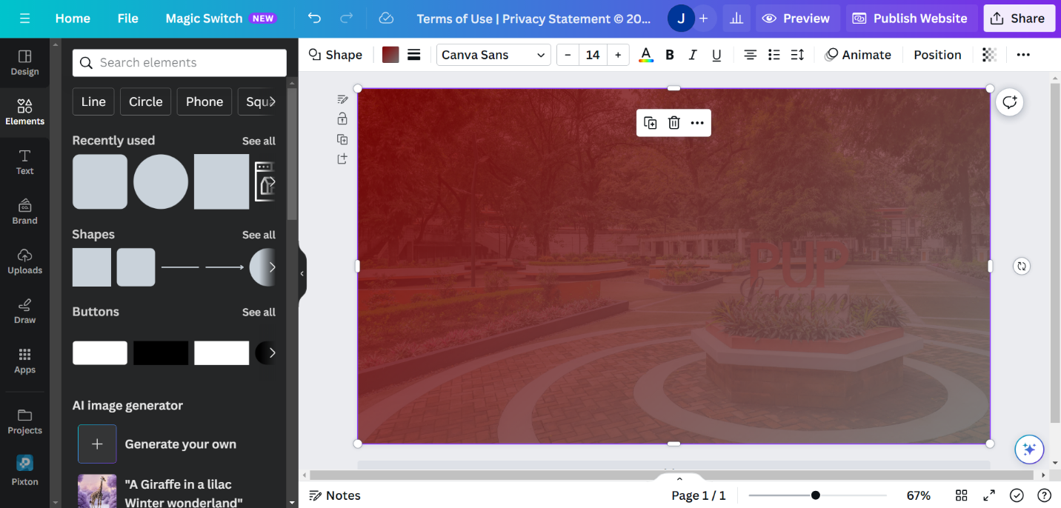

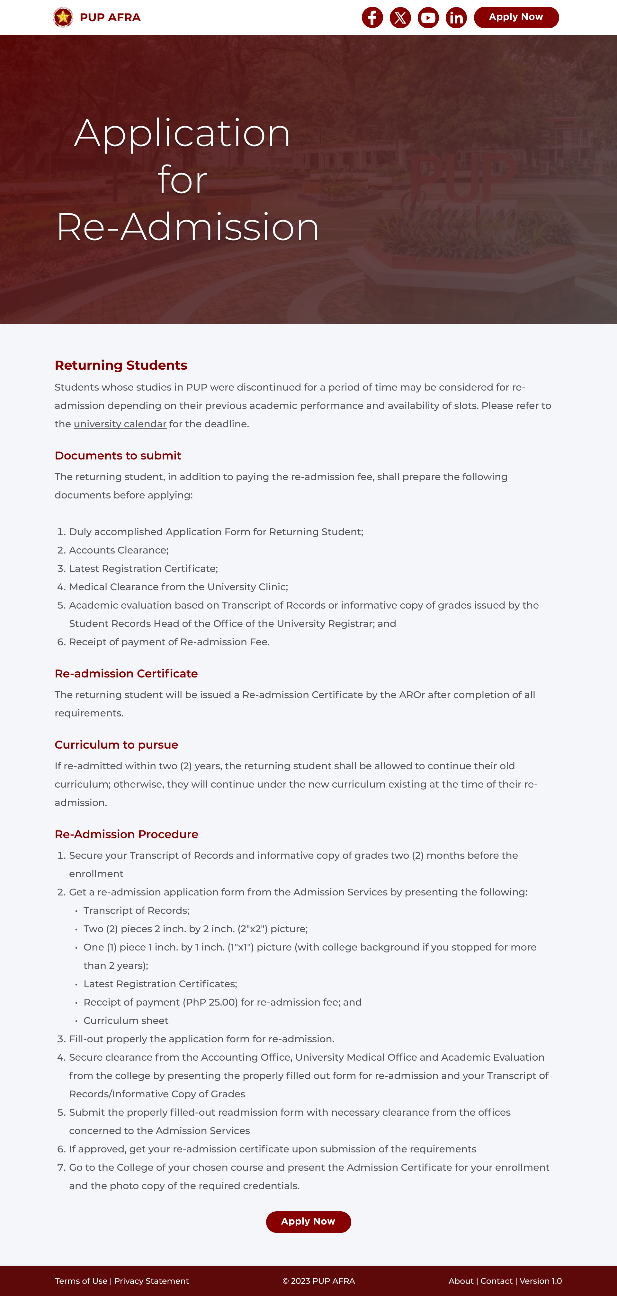



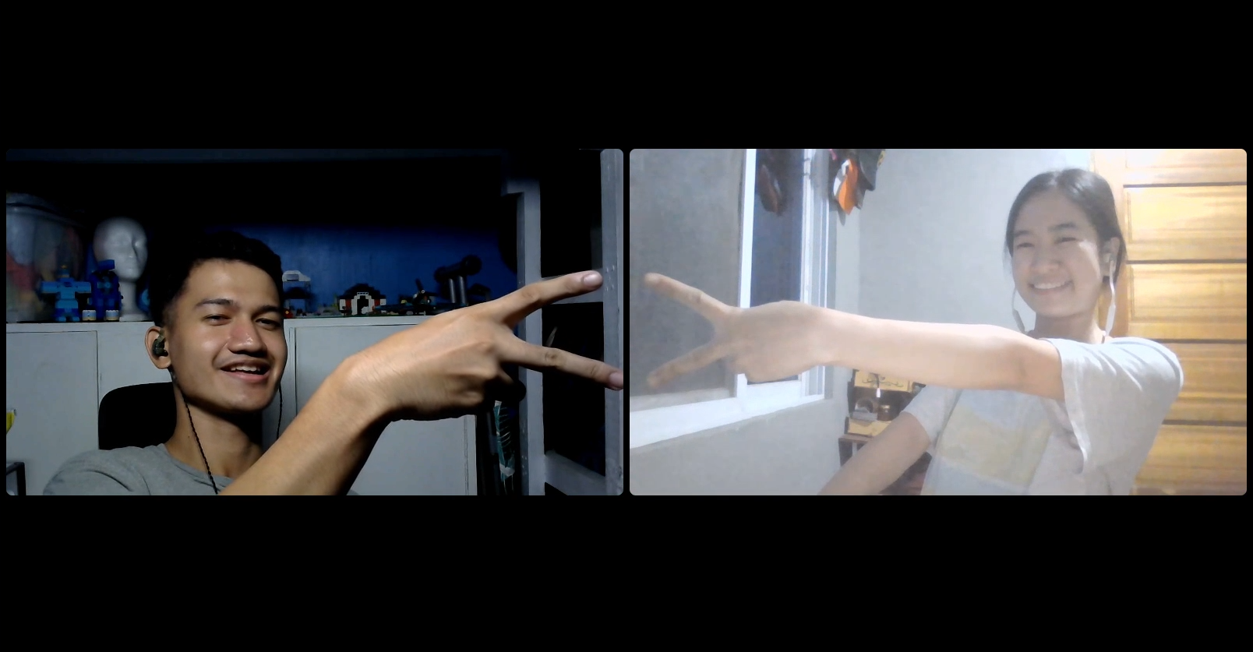

* **November 21, 2023 (5:00 PM – 11:00 PM)**
  + Continue designing the website in Figma.
    - Finished “Home Page” design.
    - Finished “Upload Documents” design.
    - Initialize “About Page” design.
    - Added “TOP” button. Its purpose is to go to back to top once clicked. Also learned how to make the hover effect.
    - Modified the “back”, “next”, and “submit” button.
    - Modified the progress bar design because of the added “Upload Documents” page.
  + Used Canva for editing pictures for the homepage.
  + Enhance the prototyping experience for wireframes.
  + **Next Step:**
    - Consultation for the feasibility of the project (Nov. 28, 2023).

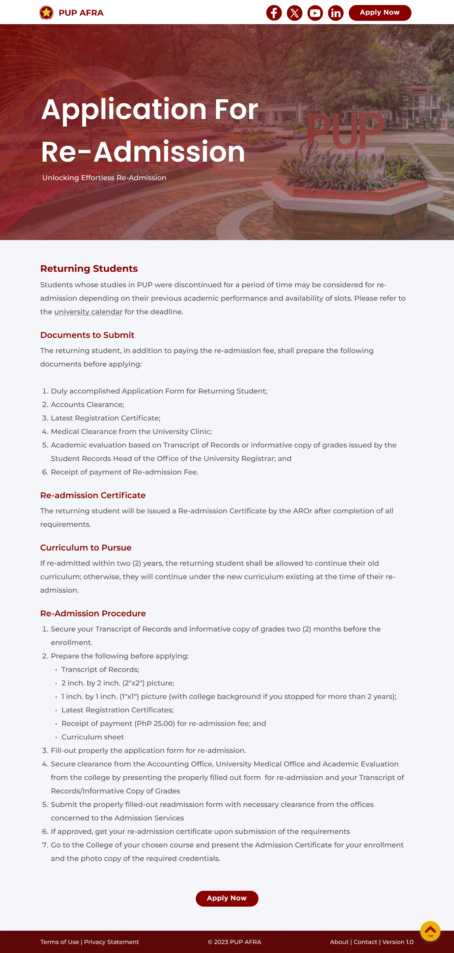

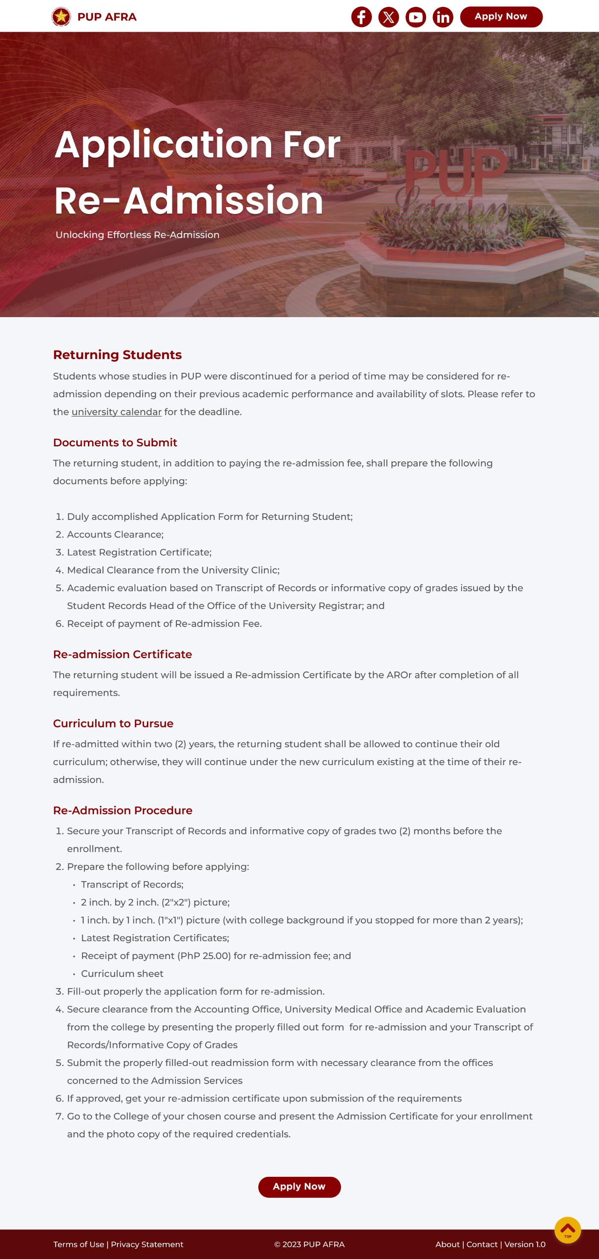

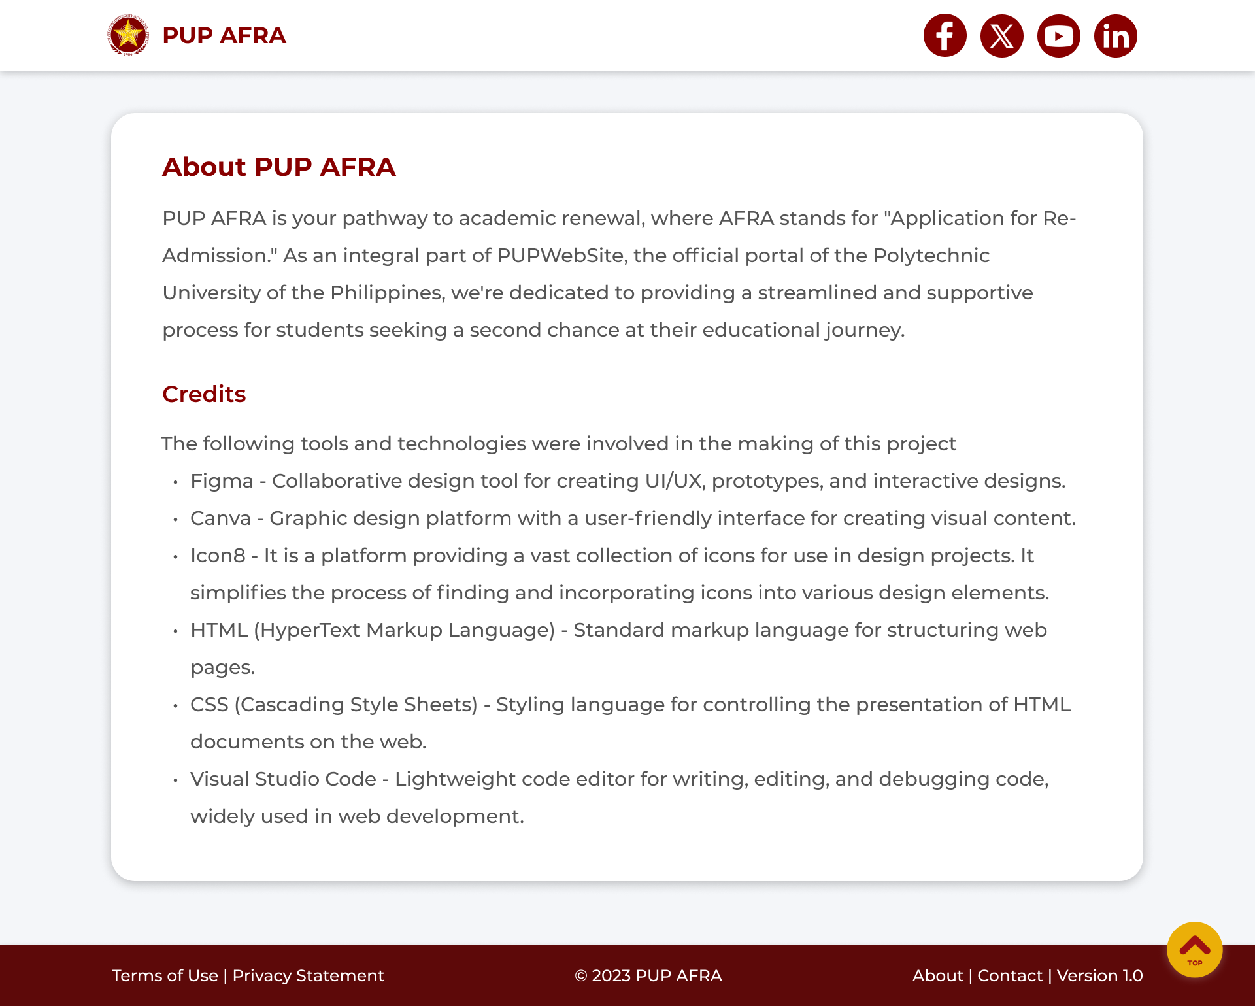

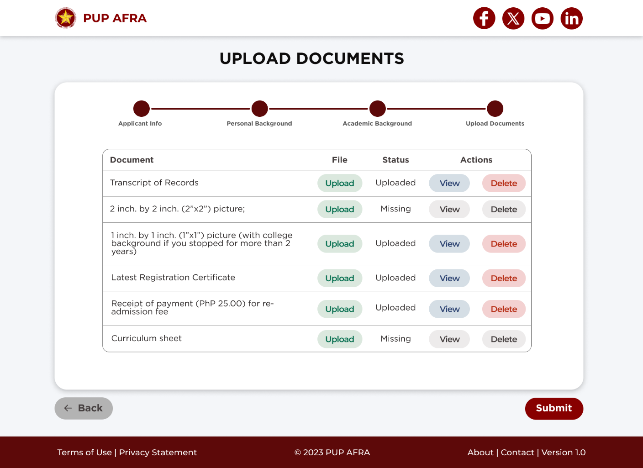

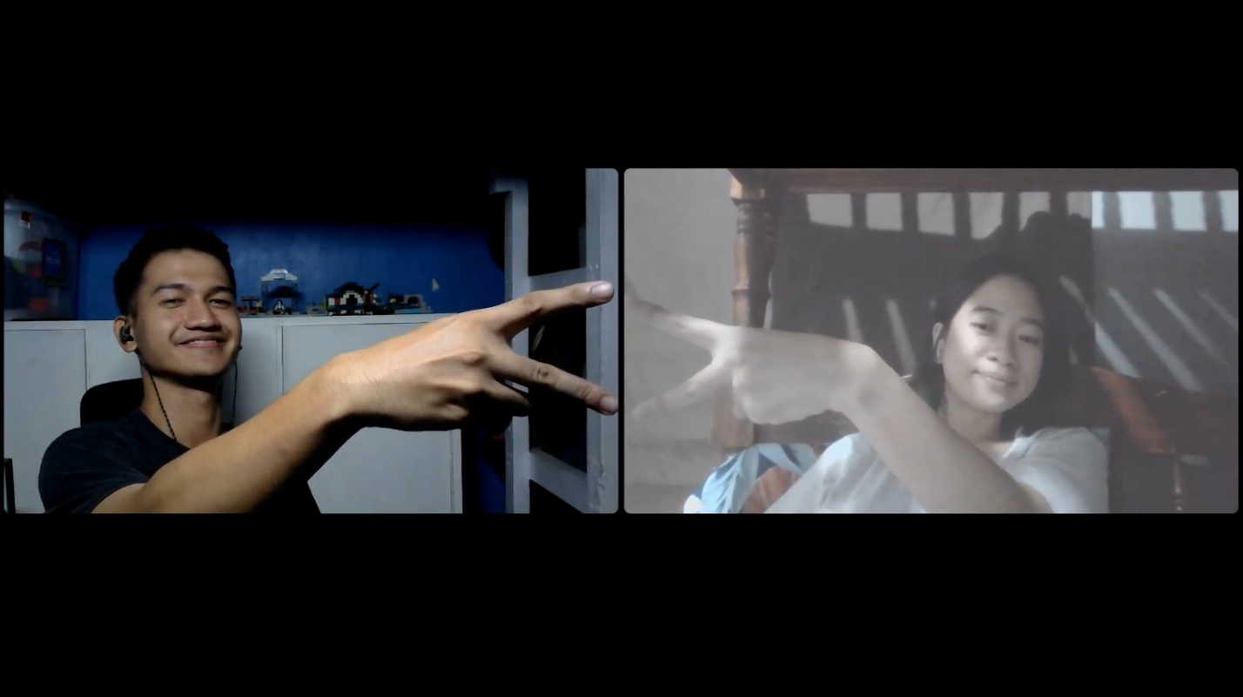

* **December 21, 2023 (6:00 PM – 6:50 PM)**

**First Consultation with Ma’am Sales (Notes)**

Recommendations:

**1. Header**

- Remove social media links from the header, leaving only the "Apply Now" button as it is not a main feature of the page.

- Move social media links to the footer.

**2. Contacts**

- Generate a dummy email address for general concerns.

- Apply a fade effect when the contact is clicked, indicating that it has been copied to the clipboard.

**3. Progress Bar**

- Enhance the progress bar by changing the color or turning it into a complete shape when moving to the next step.

- Enable users to navigate back to each page by clicking the dots for easy navigation.

**4. Address Locator**

- Do the coding of the Philippine Address Locator at the end due to its advanced JavaScript requirements.

**6. Additional Approval Status on Header**

- A new header element to display the approval status per department.

**7. Login Page**

- Create a login page; when "Apply Now" is clicked, route to a modal pop-up box for login.

- Prompt users to log in with SIS credentials or using the SIS login page.

**8. Temporary Status**

- Allow the addition of a temporary status in the form for testing purposes (can be not really working).

**9. Profile/Change Password/Sign Out**

- It is fine even if it’s not clickable or functional just for the sake of knowing that it is secure or it works that way.

- Exclude unnecessary fields/pages for the profile.

- Ensure that the sign-out option is working, and it redirects to the login page.

**Additional Notes**

- Implement validation for required fields.

- Keep email confirmation simple by adding it in HTML, not in the API, for a straightforward confirmation.

- Skip creating a summary of the page to simplify the process.

- Submit the PDF of the form upon completion.

**Next Step:**

* + - Modify the changes based on the consultation notes.

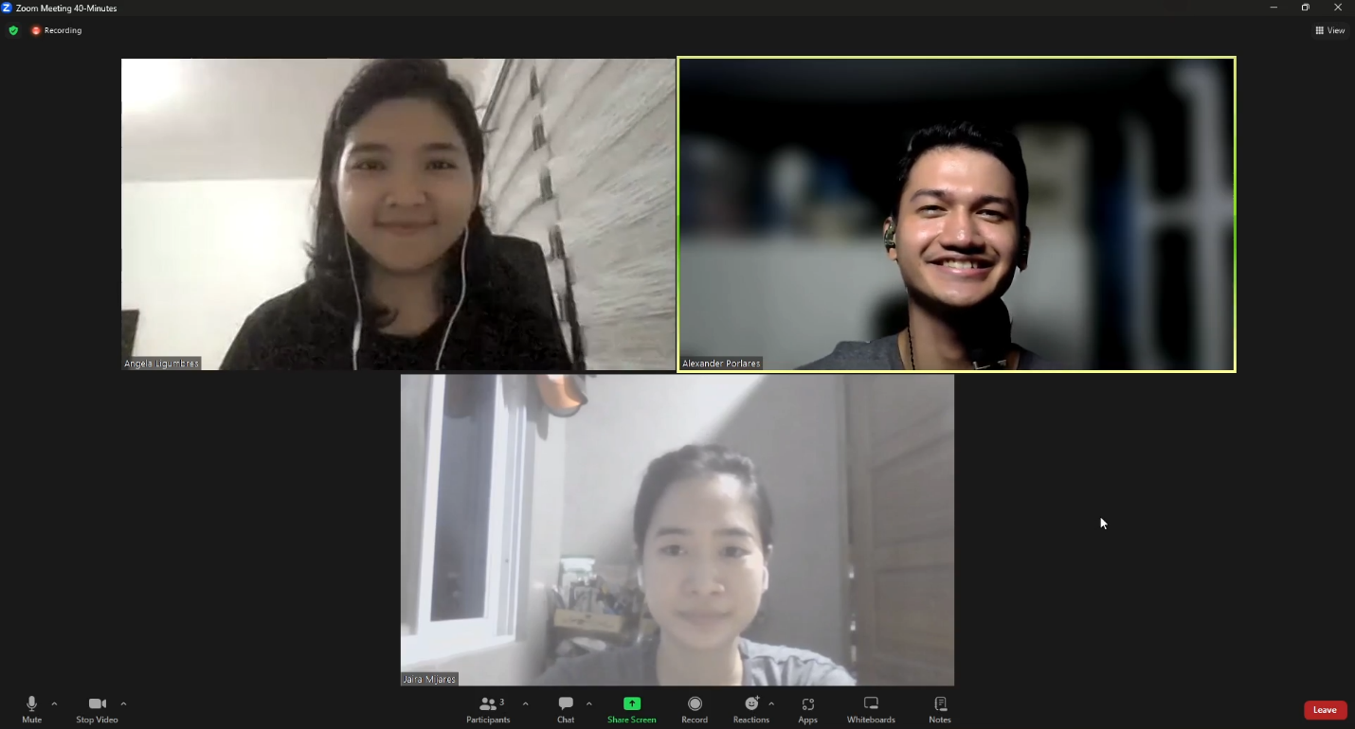

* **January 12, 2024 (9:30 PM – 1:00 AM)**
  + Modified the header:
    - Removed socials
    - Added “Application Status”
    - Added “Profile Settings” Icon
  + Designed the Login Page and Application Status Page

**Next Step:**

* + Finalized the Figma Design
  + Code the front end



